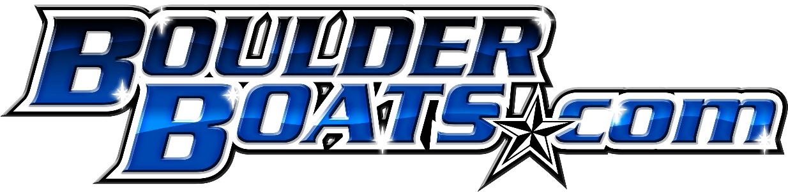

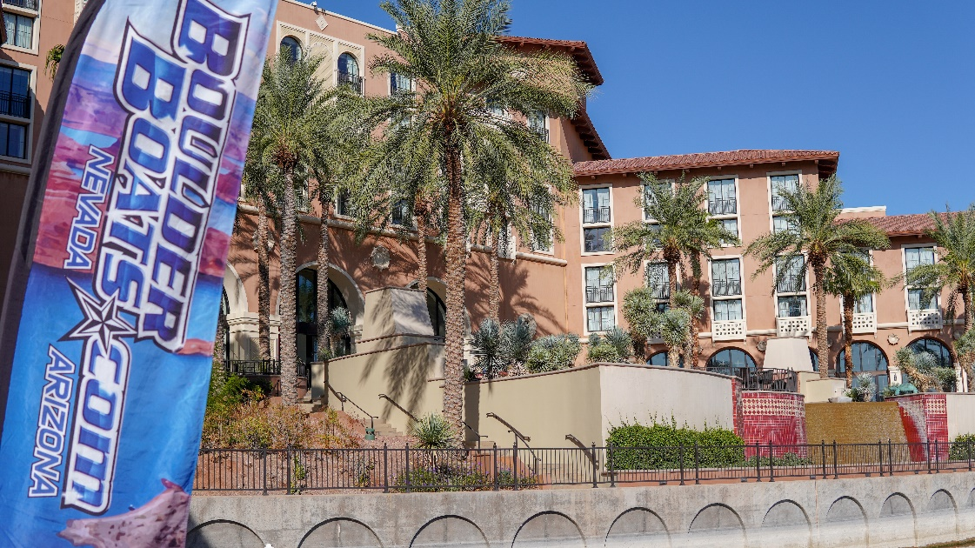
On a sun-bathed day with a nice high of 87 degrees on the serene lakeside of Lake Las Vegas, Boulder boats held one of their many Lake Las Vegas Demo Days. An opportunity for those individuals looking for a new boat to get out and see how they perform on the water.
Looking at a boat on a trailer, in a showroom or on a lot is great. But why not have the opportunity to take it out on the water. With the ability to see how all the systems work, the boat rides, and how well it performs could be the difference in your choice of make and model.
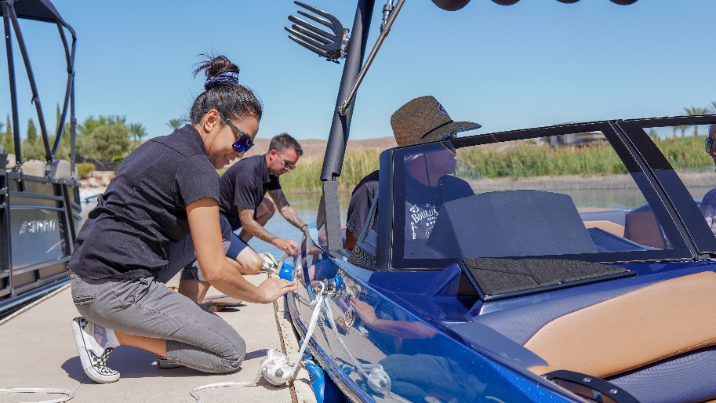
Boulder Boats comes in with the help of our staff, and we can deliver this on water demo opportunity directly to you. We had at this specific demo day; a 2019 Chaparral Vortex 223 jet boat, a 2019 Starcraft SLS3 pontoon and finally a brand new 2020 Axis A24. I will get to more about those specific boats later.
With customers arriving and filling the dock, we were able to take out ten groups of individuals for their on-water experience. With nine slots available, we always have room for those last-minute walk-ups or those passing by. However, it is best to preschedule and take advantage of the incentives offered!

The Boats

2019 Starcraft SLS3

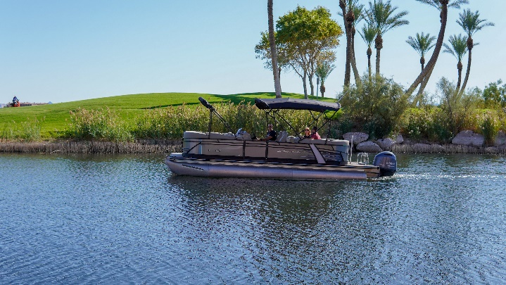
Let's start by highlighting one of our favorites at the demo day, the 2019 Starcraft SLS3. Starcraft has been making fiberglass boats since the late 1950s and in1965, released the world's first high-performance aluminum fishing boat deep-v hull. Fast forward into today with their constant innovation and revolutionary HMX pontoon tubes, Starcraft has the pedigree for an excellent pontoon boat.

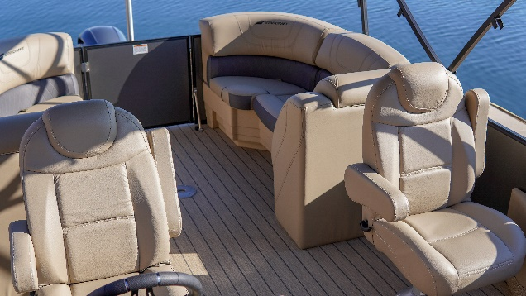
Matched with the performance of the Yamaha 200 outboard motor, this SLS3 not only feels great on the water but gets up to cruising speed very quickly. This performance allows for the ability to waterski/wakeboard/tube off the back. Yes, you heard us right, you can do pretty much anything behind this pontoon as you could in a traditional I/O boat. The one thing you can't is lounge comfortably in the lay-z-boy like drivers and passengers' chairs. Accompanied by a kicker sound system and double bimini, you have yourself the ultimate all-day comfort boat for the whole family and some!

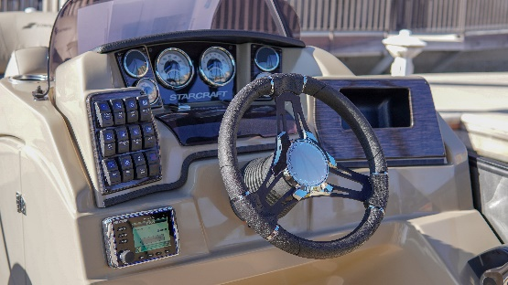
The fundamental basics of a Starcraft Pontoon Boat make for a great time to relax and play on the water. An awesome pick for a day on the water!

2019 Chaparral Vortex 223

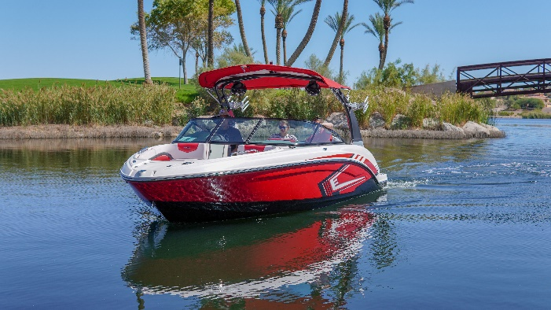
Power, agility, and fun-packed into a 22' package and for those looking for the enjoyment of all aspects, the Chaparral 223 Vortex is your choice. Our 2019 Vortex boat turned a lot of heads on the dock and plenty of smiles on the faces of those who had the chance to take it out for a rip.
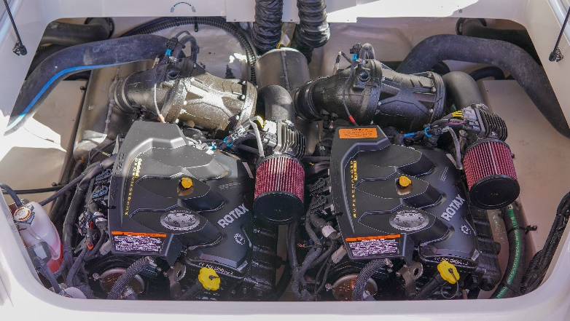
Power by twin Rotax Supercharged Jet motors, this 223 produces 400 hp getting you up to 50+ MPH. Aside from the speed, this Vortex 223 can turn on a dime. The Vortex 223 is similar to a jet ski. It uses jet propulsion to move it through the water, so nothing is hanging under the V hull line aiding in its corner ability and low water deadrise.
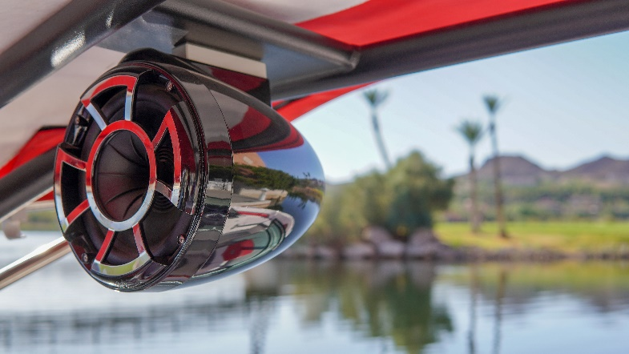
When it comes to comfort and convenience, the Vortex 223 delivers with its standard tower (VRX Model not VR) and optional board racks and speakers. Keep your boards handy on the outside of the rack and away from the interior. It will keep the great sound from the tower speakers on the inside. Facing backward toward the rider or the beach, these speakers pack a punch, delivering crisp sound.

We love the Vortex 223 because of the low water capability. This boat allows you to travel through shallow bodies of water, traditional V-Drive and I/O models typically can't get access. Which means, for the inner explorer in you, you can go farther up the river or deeper into that cove you always wanted to check out.

2020 Axis A24

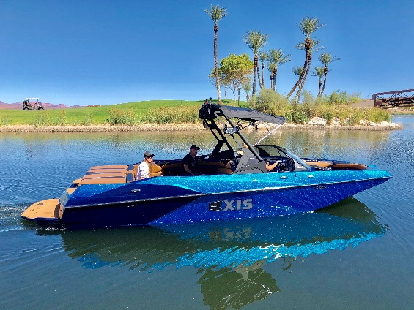

Ahhh can you smell that new boat smell? Fresh out of the wrap, we had a brand new 2020 Axis A24 on the water. This Axis turned heads with its aggressive color scheme, matching blues to a tan interior.

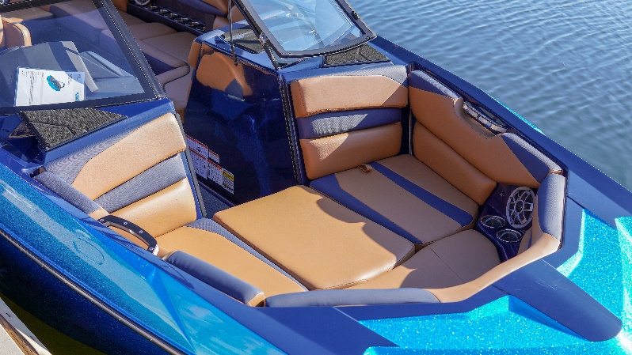

Big Boat = Big Storage. The 24’ A24 allows for the most storage space of the Axis lineup. Adding in the increased seating and you have enough room for all your things, including the kitchen sink. The Monsoon M5Di producing 410hp is plenty of power to get you up and out of the water quickly and still produce plenty of speed to get you from spot to spot.

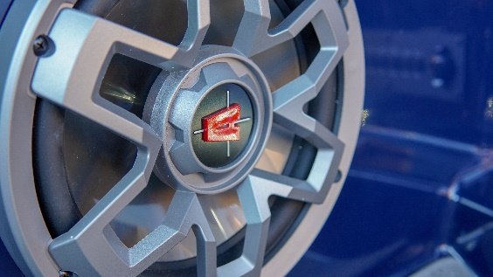
Wet Sounds speakers all around, including four on the tower, you have enough power to make the world hear your go down the lake. Blast your favorite tunes inside while cruising or dial the sound out to the tower speakers to get motivated to land that 360, the possibilities are endless.

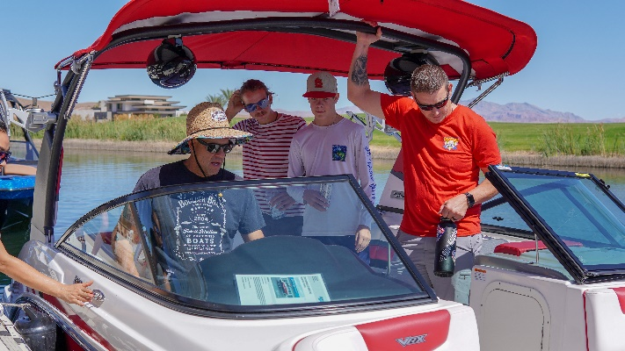
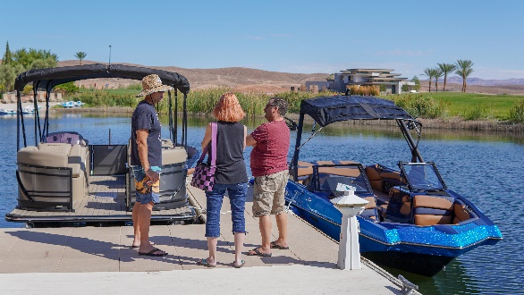
Overall the event went off without a hitch. Beautiful weather for a September in the southwest, not too hot and not too cold. With smiling faces all around, it’s safe to say every individual who came out had a blast. Many questions were answered, and minds were filled with new dreams of walking up to their brand-new boat. We thank the Westin Hotel and Lake Las Vegas for helping us with the event and providing some gift cards to those who attended to Rick’s Café and Lake Las Vegas Watersports. With your help, we wouldn’t have been able to deliver to our customers.
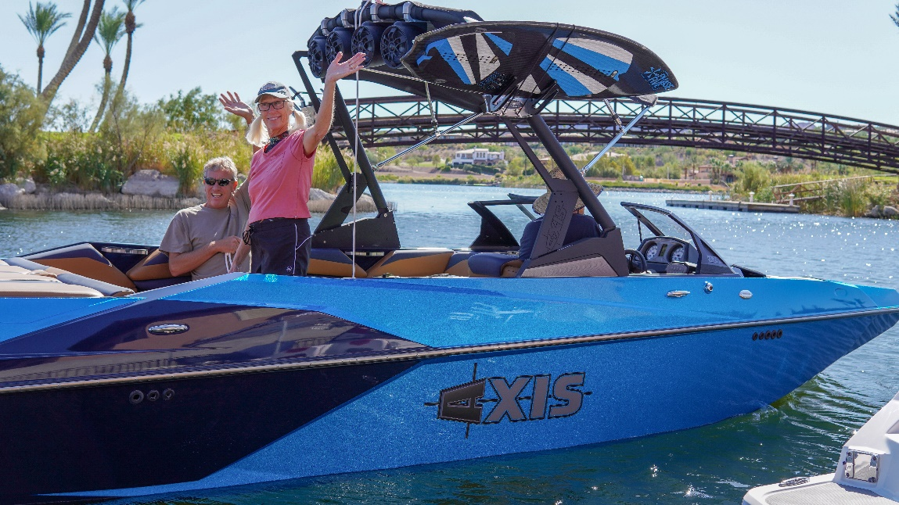

For more information on the next Boulder Boats Lake Las Vegas Demo Day, contact marketing@boulderboats.com or give us a call at (702) 293-1122 and ask for Cason Kirkpatrick. We hope to see you out on the water next time!

